Application of Scale Prevention in Oil Wellhead Flowlines in Hassi Messaoud Field using ENMAX Technology
Abdelaziz A. Noaman^{1,*} , He Li xin², Farid Chemil³, Rabah Djanati³
¹Halliburton / Algeria.
²ENMAX Company/ China.
³Sonatrach / Hassi Messaoud Field.
*Corresponding Author.

Abstract
Scaling deposition is one of the most serious problems in the oil industry where water injection is used. It may occur in downhole or in surface facilities. The formations of these scales plug production lines, equipment and impair fluid flow. Their consequence could be production equipment failure, emergency shutdown, increased maintenance cost and an overall decrease in production efficiency.
The injection water with sulfate is incompatible with formation water containing barium, strontium and calcium in some zones in Hassi Messaoud field i.e., zone 14. The mixing of incompatible injected and formation waters leads to scale formation in the downhole , pipeline network and the surface facilities.
The capability and efficiency of the 6’’ ENMAX scale prevention device was tested and evaluated for a transition period on the 6’’ wellhead flowlines of wells MD287 and MD525 in Hassi Messaoud field to solve the scale formation problems in the wellhead flowlines and avoid any production shortfalls from these two wells. Regular samples were taken upstream and downstream of the 6’’ ENMAX device from the wellhead flowlines of those two wells to analyze the total suspended solid, magnesium ions, salinity, specific gravity, pH and calcium ions . Also, daily pressure and oil flowrate monitoring upstream and downstream ENMAX device were recorded daily to avoid any plugging in the ENMAX device. Scale coupons were installed upstream and downstream ENMAX device for ENMAX device evaluation.
The scale formation was measured before installing the 6’’ ENMAX device on the wellhead flowlines of those two wells and after 6 months to check the efficiency of the ENMAX device. Comparisons were conducted between the weight of scale coupons downstream and upstream ENMAX device and also the between the analyses of the water sample upstream and downstream ENMAX devices.
It has been found that the ENMAX devices succeeded to prevent formation of scales on the wellhead flowlines of these wells. Its highly recommended to keep the two ENMAX devices installed on the wellhead flowlines of wells MD287, MD525 as it is and install other ENMAX devices either on the well downhole or on the pipeline network to solve the scale formation in Hassi Messaoud field.
Keyword: ENMAX, Scale coupon, Barium Sulphate, Hassi Messaoud field, wellhead flowline.
1. Introduction
Hassi Messaoud is the largest oil field in Algeria, located approximately 650 kilometers southeast of Algiers as shown in figure 1. Hassi Messaoud oil field was discovered in 1956, is the largest oil filed in Algeria about 2000 km², including over 1000 wells. It was developed and is currently operated by the Algerian state-owned company Sonatrach and is also the largest oil field in Algeria[1,2].
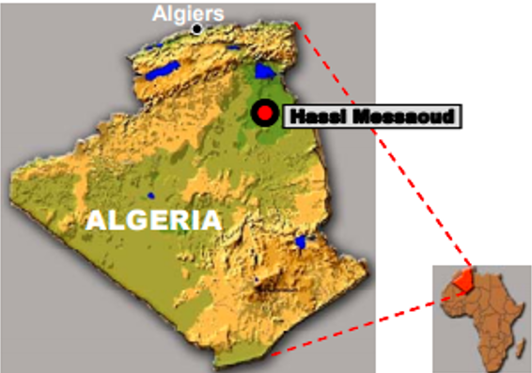
Figure 1: Hassi Messaoud Field Location Map [3].
The total proven reserves of the Hassi Messaoud oil field are around 6.4 billion barrels (870×106 tones), and production is centered on 350,000 BOPD (56,000 m³/day). Most of the associated gas is reinjected into the reservoir to improve oil recovery and more recently, this has been augmented with gas from the other fields in the region. Hassi Messaoud field is divided into two production fields (North and South) as illustrated in figure 2[3-5].
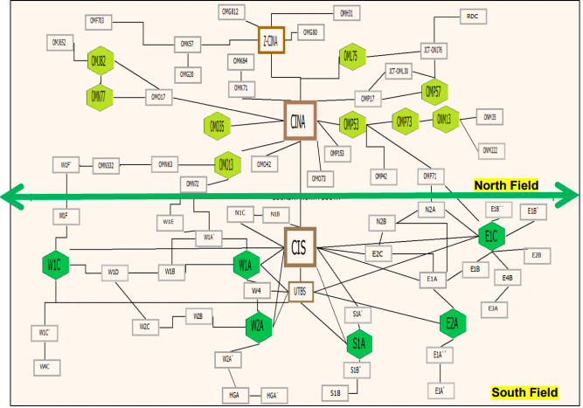
Figure 2: North and South Fields in Hassi Messaoud[Sonatrach Data 2020].
Two main classifications of scales are known; inorganic and organic scales and the two types are mutually inclusive, occurring simultaneously in the same system, referred to as mixed scale [6]. Mixed scales may result in highly complex structured scales that are difficult to treat. Such scales require aggressive, severe and sometimes costly remediation techniques[7]. Paraffin, wax, asphaltenes and gas hydrates are the most often encountered organic scales in the oil industry[8].
Inorganic scales refer to mineral deposits that occur when the formation water mixes with different brines such as injection water. The mixing changes causes reaction between incompatible ions and changes the thermodynamic and equilibrium state of the reservoir fluids. Supersaturation and subsequent deposition of the inorganic salts occur[9-11]. The most common types of inorganic scales known to the oil/gas industry are carbonates and sulfates; sulfides and chlorites are often encountered [12].
Table 1 reveals the different types of scales in the oil industry, these scales are sulfates such as calcium sulfate (anhydrite, gypsum), barium sulfate (barite), and strontium sulfate (celestite) and calcium carbonate. Other less common scales have also been reported such as iron oxides, iron sulfides and iron carbonate[13-15].
Table 1: Common Oil Field Scales .
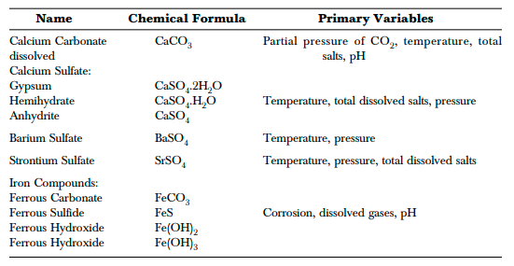
Calcite deposition is generally a self-scaling process. The main driver for its formation is the loss of CO₂ from the water to the hydrocarbon phase(s) as pressure falls. This removes carbonic acid from the water phase, which had kept the basic calcite dissolved. Calcite solubility also decreases with decreasing temperature (at constant CO₂ partial pressure)[16-18]. Iron sulfide scales are almost ubiquitous when hydrogen sulfide is produced—frequently the result of tubular corrosion in the presence of H₂S[19].
Scale deposition is one of the most serious oil field problems that inflict water injection systems primarily when two incompatible waters are involved[20]. Barite scales are generally the result of mixing incompatible waters , two waters are incompatible if they interact chemically and precipitate minerals when mixed[21]. Typical examples are sea water, with high concentration of sulfate ion and formation waters, with high concentrations of calcium, barium, and strontium ions. Mixing of these waters, therefore, could cause precipitation of calcium sulfate, barium sulfate and/or strontium sulfate[22,23].
Scale formation in surface and subsurface oil and gas production equipment has been recognized to be a major operational problem. It has been also recognized as a major cause of formation damage either in injection or producing wells. Scale contributes to equipment wear and corrosion and flow restriction, thus resulting in a decrease in oil and gas production[24,25].
Barium sulfate (BaSO₄) is one of the most difficult types of scale to inhibit in oil and gas production systems because of its physical hardness and its chemical and thermal stability. Barium sulfate restricts the flow in the oil and gas pipelines when it builds up, costing the oil and gas industry hundreds of millions in lost production. Barium sulfate is the inorganic compound and it’s a white crystalline solid that is odorless and insoluble in water[26,27].
Scale prevention using chemical inhibitors, applied either by continual injection or by squeeze treatment into the near wellbore formation, has generally been regarded as the most cost-effective solution to the problem. BaSO₄ scale treatment must focus mainly on its prevention using scale-control chemicals[28-32].
The objective of this work is to study and evaluate the efficiency, suitability, and capability of the ENMAX scale prevention device installed on the 6’’ wellhead flowlines of wells MD287 and MD525 in Hassi Messaoud field to solve the scale formation on the wellhead flowlines of those wells and to avoid any production shortfalls. Regular samples were taken upstream and downstream the 6’’ ENMAX device from the wellhead flowlines of those two wells to analyze the TSS and water quality. Also, daily pressure and oil flowrate monitoring upstream and downstream ENMAX device were recorded daily to avoid any plugging in the ENMAX device. Scale coupon was installed upstream and downstream ENMAX device for ENMAX device evaluation.

2. Methodology
2. 1. ENMAX Prevention Device
ENMAX scale prevention device is a complete series of the tools used for the prevention of scale, paraffin, asphaltene deposits and rust in oil and gas industry and any heat water and cooling water systems in other industries[33].
ENMAX device is comprised of nine dissimilar metals as copper, zinc and nickel, etc., which can form a special catalyst. When fluids pass through ENMAX device, the metals enable a change in electrostatic potential of the fluids and produces a polarization effect on the liquid molecular and reduces the binding between the negative and positive ions and between the suspending particles. This catalytic action will keep the particles suspending and inhibits the ions to binding to each other to form scales, paraffin deposits, This action will also breakdown the existing paraffin or scale deposit and flushes away with the fluids. Table 2 displays the working conditions of ENMAX device.
Table 2: ENMAX Device Working Conditions.
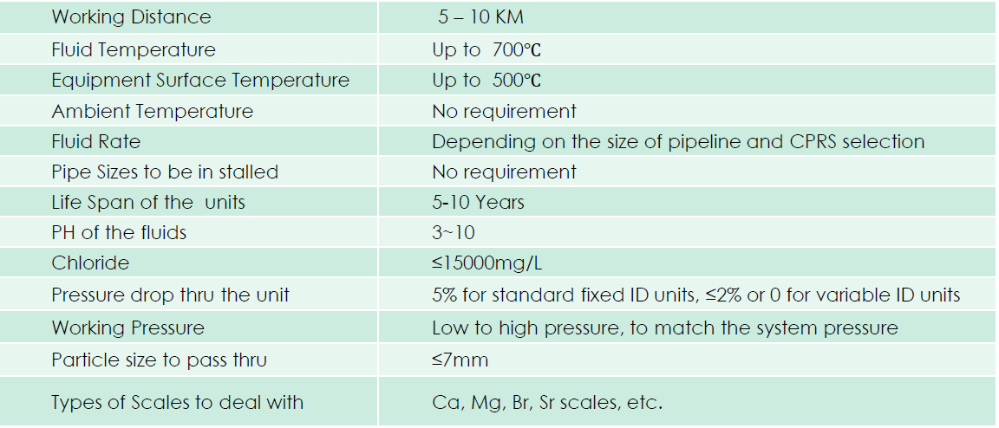
The ENMAX device has many advantages i.e., non-magnetic, non-electrical, no chemicals required, environmentally friendly, good for HP & HT operations, less downtime & replacement costs on equipment minimized or no chemical cost, Reduced or no hot oil treatment, lower bottom sludge in tank batteries , increased equipment efficiency & life, improved fuel burning & emission quality and easy installation & maintenance free.
ENMAX Technology has achieved a great success to solve the most troublesome problems with paraffin, scale, and corrosion. The systems design, material composition and metallurgical processing have been patented and proven in the USA, Canada, Mexico, China and other countries in preventing and removing corrosion, scale, paraffin, asphaltenes. ENMAX device can be installed either in the downhole or the surface lines.
Figure 3 reveals the all types of ENMAX devices used either for the downhole or the surface pipeline network.
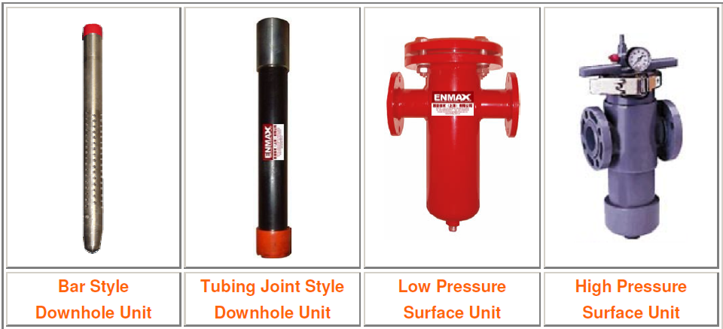
Figure 3 : Types of ENMAX Device.
2. 2. ENMAX Prevention Device Installation Requirements
Figure 4 displays the installation of the ENMAX device on the pipeline. The ENMAX device relates to the pipeline through welding flanges . The material specifications of the ENMAX device should be the same material specifications of the pipeline.
Bypass line with complete isolation valves (ball valves) should be installed for more operation flexibility and pressure gauge upstream & downstream ENMAX device should be installed for daily pressure monitoring to avoid any plugging in the ENMAX device. The direction of the flow should be identified on the ENMAX device before ENMAX device installation.
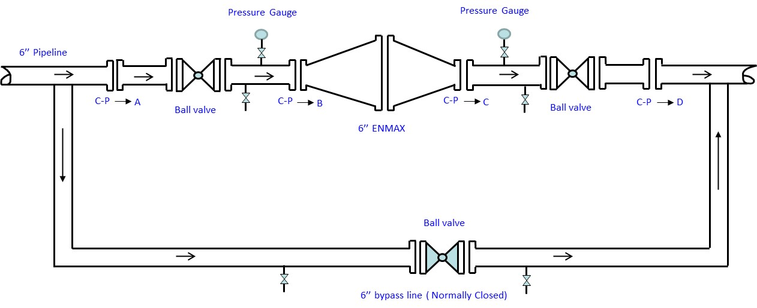
Figure 4 : ENMAX Prevention Device Installation.

2. 3. ENMAX Prevention Device Evaluation
2.3.1. Laboratory analysis
The following laboratory analyses are required to evaluate the performance of the ENMAX scale prevention device:-
- Total suspended solid (TSS) upstream and downstream the ENMAX device.
- Water quality testing upstream and downstream the ENMAX device.

23.1.1 Scale Coupons
Scale coupons should be installed upstream and downstream ENMAX devices , the following items should be considered:-
- Scale coupon testing after the proportion period by measuring the weight of sample plate upstream and downstream the test, the difference of the weights will be the scale weight.
- Scale coupons No. 1 should be installed upstream the ENMAX device. Distance should be left between the scale coupon downstream the ENMAX device and the ENMAX device itself because of the back-flow effect.
- Scale coupons No.2 should be installed downstream the ENMAX device. Distance should be left between the scale coupon downstream the ENMAX device and the ENMAX device itself.
- 1-3 months after, the samples can be monitored or weighed for evaluation of scale deposits.

2.3.2. Visual Inspection before and after ENMAX Scale Prevention Device Installation
Measure the thickness of deposits accumulated in the bottom part of the flowline of wells upstream & downstream and before & after ENMAX installation in the pipeline.

2.3.3. Pressure daily Reading Upstream and Downstream ENMAX Device
Record the daily pressure reading upstream and downstream ENMAX scale prevention device on the pipeline. When the pressure drop across the ENMAX device increase above 2 bar then the ENMAX device should be isolated for inspection and internal cleaning.

2.3.4. Oil Flowrate Daily Monitoring
Record the daily oil flowrate reading on the pipeline and observe any changes to take the proper action.

2.4 Sonatarch Data
Sonatarch in Hassi Messaoud field decided to test the ENMAX scale prevention device on the wellhead flowlines of wells MD287 and MD525 before using the ENMAX on other pipelines. 6’’ ENMAX device was installed on the 6’’ wellhead flowline of well MD287 while 8’’ ENMAX device was installed on the 8’’ wellhead flowline of well MD525.
Scale coupons, pressure gauges and water sample points were installed upstream and downstream the 6’’ and 8’’ ENMAX devices. The scale coupons and water sample points were installed 300 meter distance upstream the ENMAX device and 1000 meter distance downstream the ENMAX device for more ENMAX device evaluation
Bypass lines were also installed for more operation flexibility and to avoid any production loses during ENMAX maintenance and inspection.
Figure 5 displays the installation of ENMAX device on the wellhead flowline of well MD287 and highlight the installation of the scale coupons , water sample points upstream and downstream the ENMAX device.
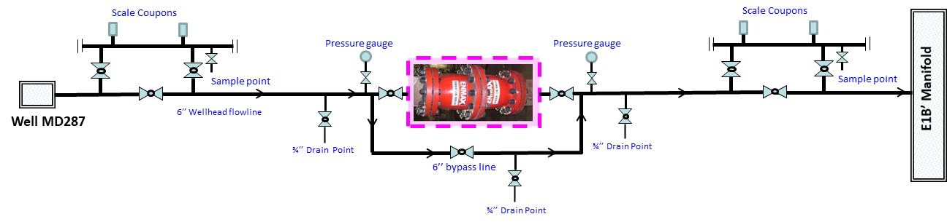
Figure 5: ENMAX Installation on the Wellhead Flowline of Well MD287.
Figure 6 reveals the installation of ENMAX device on the wellhead flowline of well MD287 and highlight the installation of the scale coupons , water sample points upstream and downstream the ENMAX device.
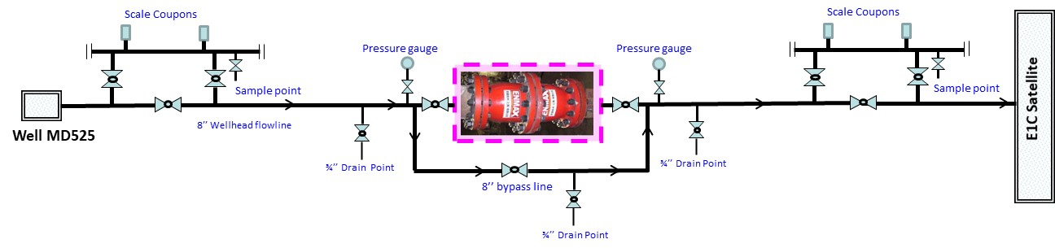
Figure 6: ENMAX Installation on the Wellhead Flowline of Well MD525.
Table 3 illustrate the oil, gas, and water flowrate for wells MD287 and MD525 based on the last well test done for these wells.
Table 3: Oil , Gas and Water Flowrates of Wells MD287 & MD525.
Well Name | Oil Flowrate , m³/hr. | Gas Flowrate , m³/hr. | Water Flowrate , m³/hr.
MD287 | 10 | 179019 | 2.5
MD525 | 1.6 | 94323 | 0.5

3. Results and Discussions
Some procedures and actions were taken to evaluate the performance of the ENMAX devices installed on the wellhead flowlines of wells MD287 and ND525, these procedures are ad follow:-
3.1 Daily Pressure and Oil Flowrate Monitoring
Pressure gauges were installed upstream and downstream the ENMAX devices installed on the wellhead flowlines of wells MD287 and MD525 for daily pressure reading. The pressure drop across the ENMAX devices should be zero but when the pressure drop increase up to 2 bar then the ENMAX device should be isolated for inspection and maintenance.
Figure 7 reveals the daily pressure monitoring upstream & downstream ENMAX device installed on the wellhead flowline of well MD287, daily wellhead pressure of wells MD287 and daily oil flowrate from wells MD287.
From figure 7, it can be noticed that the pressure difference across the ENMAX device installed on the wellhead flowline of well MD287 was zero for few months the pressure drop across the ENMAX device increased. A quick action was taken to isolate the ENMAX device for inspection and maintenance. The ENMAX device was isolated by the complete isolation valves upstream and downstream the ENMAX device. The 6’’ bypass line was opened to avoid any production shortfall from this well. The ENMAX device was dismantled and relocated to the maintenance shop to open and inspect its internals. It has been found that the internals were damaged. The vendor of ENMAX device recommended to change the design of the internals and he sent the new internals with a new design to avoid any future damage in the internals.
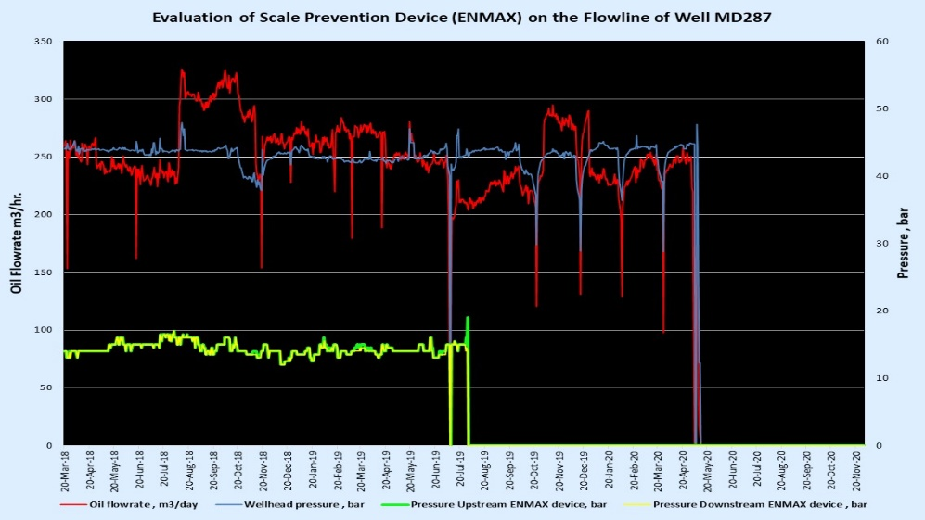
Figure 7: Daily WHP, Pressure Upstream and Downstream ENMAX and Oil Flowrate for well MD287.

Figure 8 illustrates the daily pressure reading upstream & downstream ENMAX device installed on the wellhead flowline of well MD525, daily wellhead pressure of wells MD525 and daily oil flowrate from wells MD525.
From figure 8, it can be noticed that the pressure difference across the ENMAX device installed on the wellhead flowline of well MD525 was zero for few months the pressure drop across the ENMAX device increased. A quick action was taken to isolate the ENMAX device for inspection and maintenance. The ENMAX device was isolated by the complete isolation valves upstream and downstream the ENMAX device. The 6’’ bypass line was opened to avoid any production shortfall from this well. The ENMAX device was dismantled and relocated to the maintenance shop to open and inspect its internals. It has been found that the internals were damaged. The vendor of ENMAX device recommended to change the design of the internals and he sent the new internals with a new design to avoid any future damage in the internals. The new internals were installed and the ENMAX device was in service again.
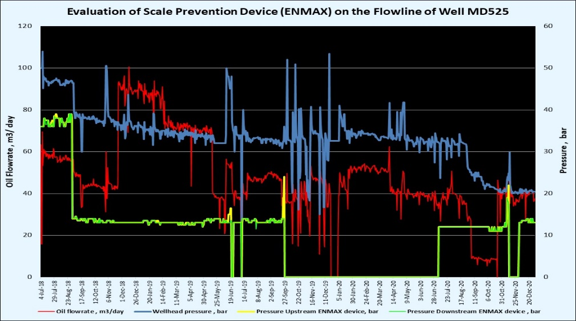
Figure 8: Daily WHP, Pressure Upstream and Downstream ENMAX and Oil Flowrate for well MD525.

Figure 9 shows the ENMAX internals old design. These internals were damaged due to the accumulation of the deposits on these internals. The ENMAX devices were isolated and bypassed until replacing these internal with a new one.
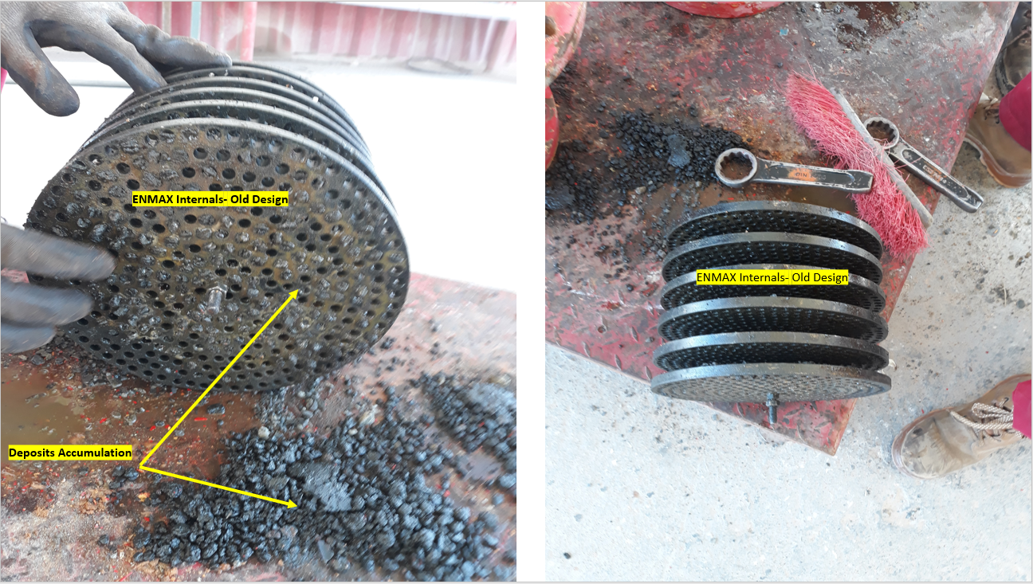
Figure 9: ENMAX Internals Old Design.
Figure 10 displays the new internals design for the ENMAX devices as per ENMAX vendor recommendation to avoid any possible damage in the internals. The new internals include 6 discs and 7 cylindrical support wit bar to support the discs during deposits accumulation.
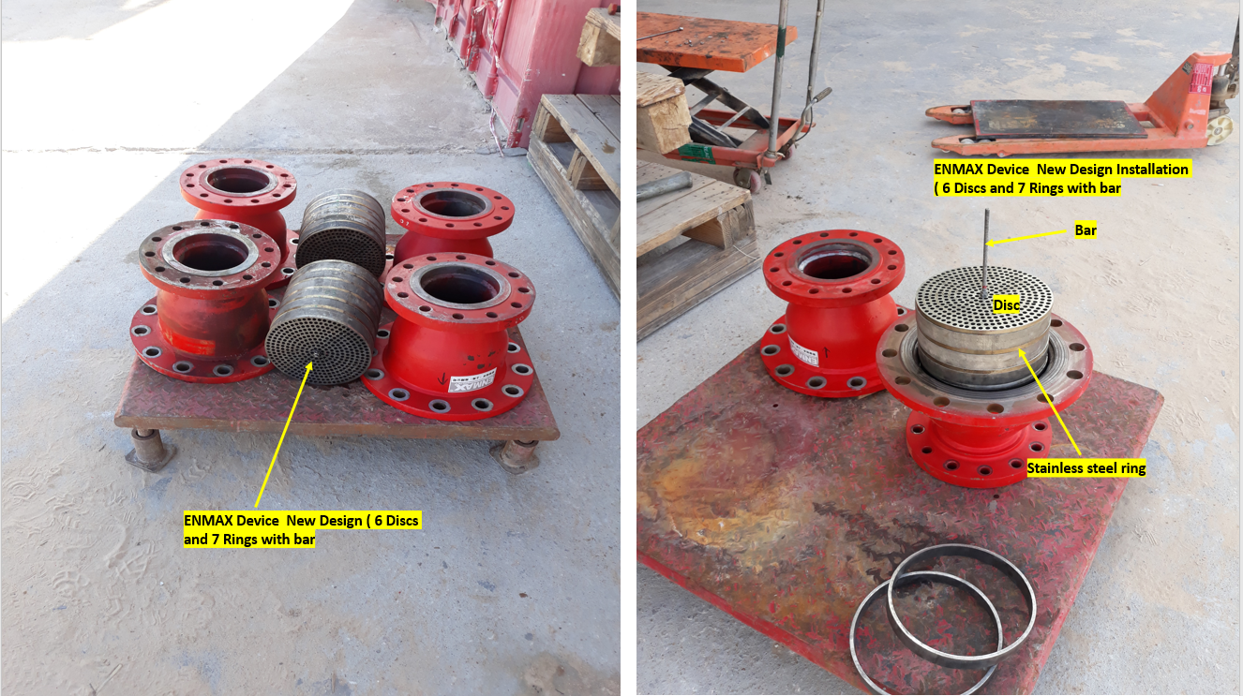
Figure 10: ENMAX Internals New Design.
3.2 Scale Coupons Inspection
Figure 11 reveals the scale coupons upstream and downstream ENMAX device installed on the wellhead flowline of well MD287 after completing the test period which is 6 months. From figure 11, it can be noticed that some scales were formed on the scale coupons installed upstream the ENMAX device while no scales were formed on the scale coupons installed downstream the ENMAX device.
The weight of scales formed on the scale coupons downstream the ENMAX device installed on the wellhead flowline of well MD287 is 30 mg while the weight of scale formed on the scale coupons upstream the ENMAX device is 34 mg. this means that the ENMAX device is working well and prevented any scales formation on the wellhead flowline of this well. The analyses of the scales formed on the scale coupons are 80 % barium sulphate , 18 % organic, 1% oxides and 1% carbonate.
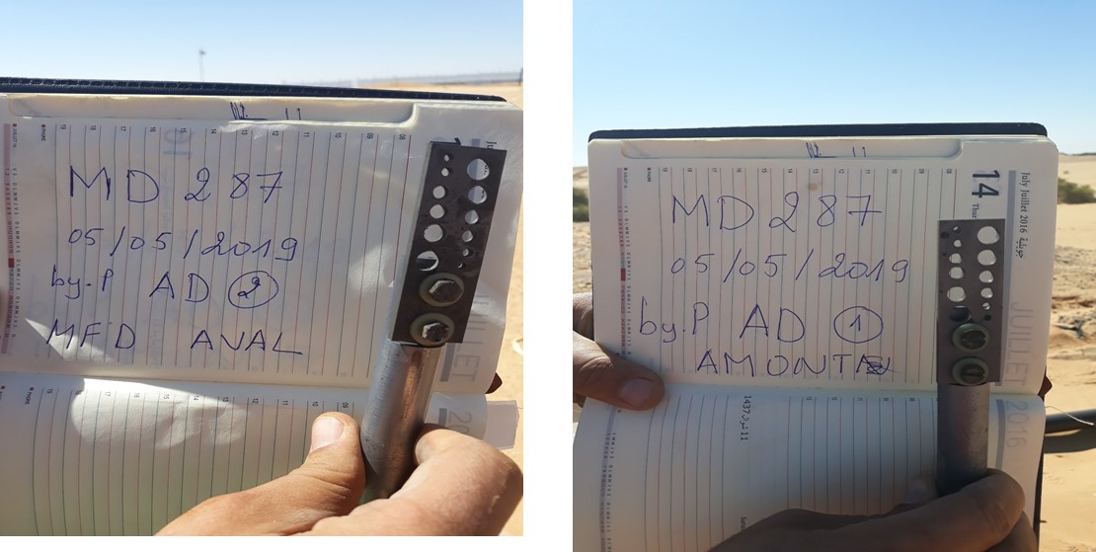
Figure 11: Scale Coupons Upstream and downstream ENMAX on well MD287.
Figure 12 reveals the scale coupons upstream and downstream ENMAX device installed on the wellhead flowline of well MD525 after completing the test period which is 6 months. From figure 12, it can be noticed that some scales were formed on the scale coupons installed upstream the ENMAX device while no scales were formed on the scale coupons installed downstream the ENMAX device.
The weight of scales formed on the scale coupons downstream the ENMAX device installed on the wellhead flowline of well MD 525 is 37 mg while the weight of scale formed on the scale coupons upstream the ENMAX device is 58 mg. this means that the ENMAX device is working well and prevented any scales formation on the wellhead flowline of this well. The analyses of the scales formed on the scale coupons are 78% barium sulphate , 18 % organic , 2% oxides and 2% carbonate.
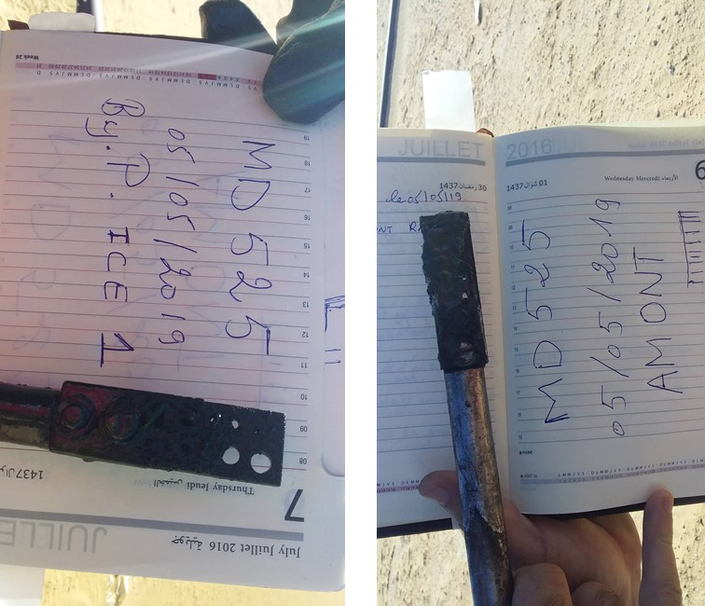
Figure 12: Scale Coupons Upstream and downstream ENMAX on well MD525.

3.3 Visual Inspection
Visual inspection of the wellhead flowlines upstream & downstream the ENMAX device and also visual inspection the ENMAX device itself after opening the ENMAX device for cleaning and inspection are highly recommended to judge the efficiency of the ENMAX device.
Figure 13, 14 and 15 illustrate the wellhead flowline of well MD287 upstream & downstream ENMAX device and the ENMAX device itself. From these figures, it can be noticed that no scales were formed downstream the ENMAX device and some scales were formed upstream the ENMAX device. The ENMAX device is working well.
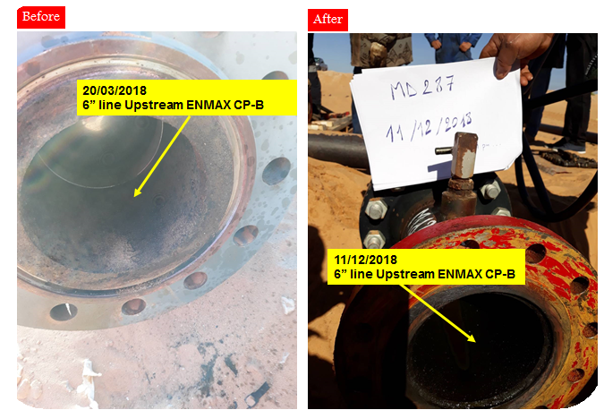
Figure 13: ENMAX Device Opening on the Wellhead Flowline of Well MD287.

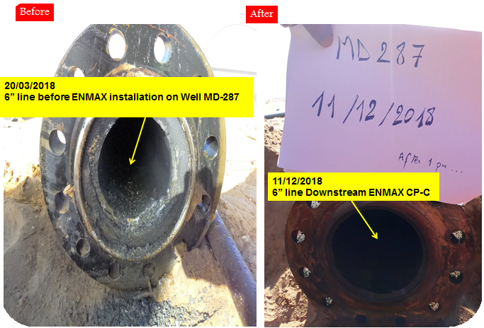
Figure 14: ENMAX Device Opening on the Wellhead Flowline of Well MD287.
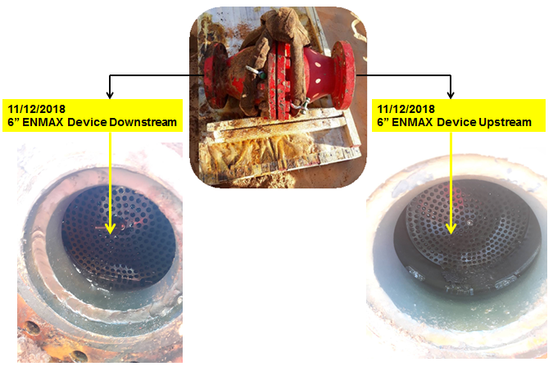
Figure 15: ENMAX Device Opening on the Wellhead Flowline of Well MD287.
Figure 16, 17 and 18 illustrate the wellhead flowline of well MD525 upstream & downstream ENMAX device and the ENMAX device itself. From these figures, it can be noticed that no scales were formed downstream the ENMAX device and some scales were formed upstream the ENMAX device. The ENMAX device is working well.

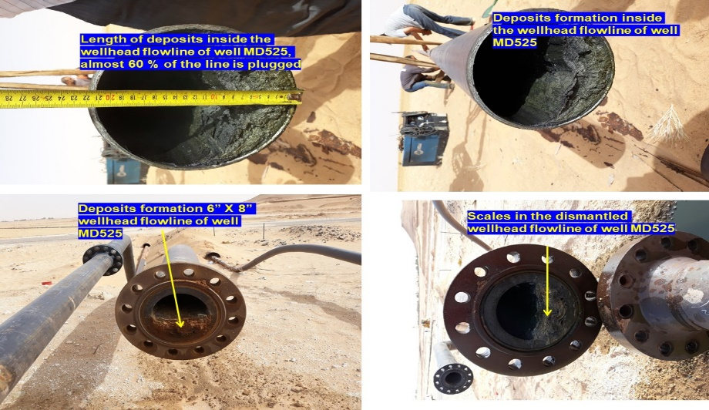
Figure 16: ENMAX Device Opening on the Wellhead Flowline of Well MD525.
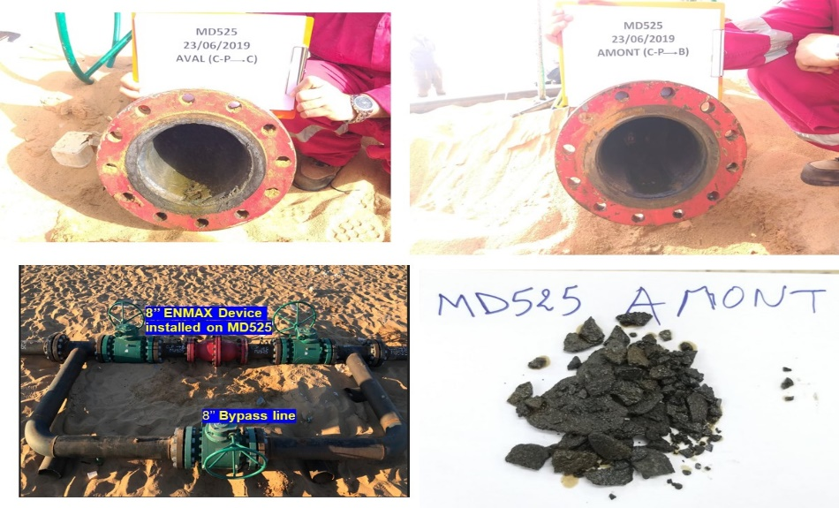
Figure 17: ENMAX Device Opening on the Wellhead Flowline of Well MD525.

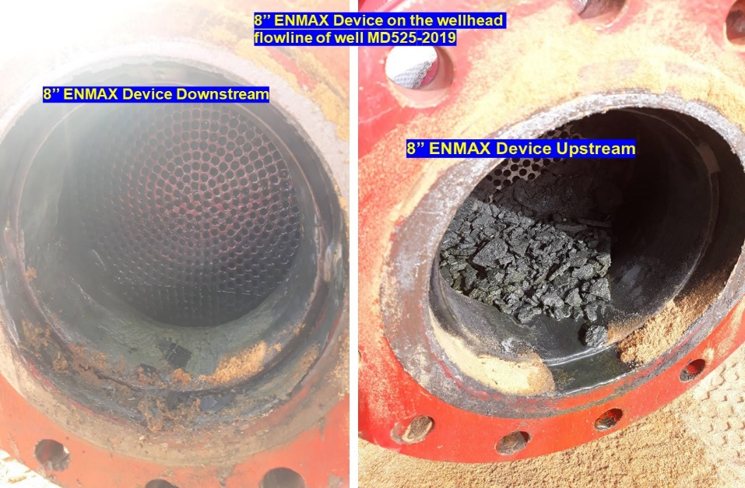
Figure 18: ENMAX Device Opening on the Wellhead Flowline of Well MD525.
Figure 19 reveals the ENMAX internals cleaning and installation. Each disc should be installed with one ring in the bar and the disc and cylindrical support must be tightened to avoid any small spaces.
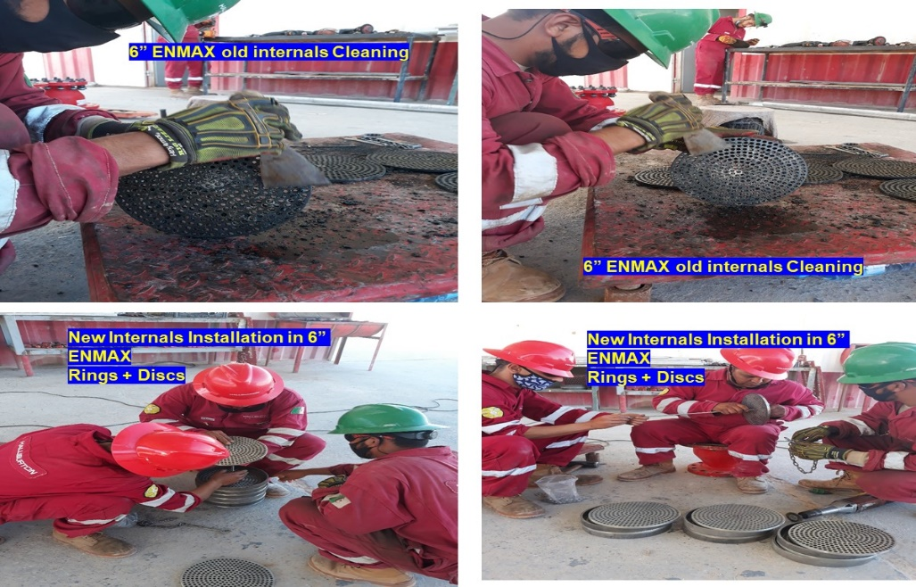
Figure 19: ENMAX Internals Cleaning and Installation.
3.4 Deposits Analysis
Table 3 displays the analyses of scales found in the 6’’ wellhead flowline of well MD287 before installing the ENMAX device. From table 3, it can be noticed that barium sulfate is the main component of the scales in the wellhead flowline of well MD287.
Table 3: Sample Analysis on Well MD287.
Sample Analysis for the Scale found in the 6'' Flowline of Well MD287 before ENMAX Device Installation
Item | Percentage , % | Remarks
BaSO₄ | 90
Salts | 1.6
CaSO₄ | 1.4
MgSO₄ | 3
Sand | 4
Total | 100

Table 4 reveals the analyses of scales found in the 6’’ wellhead flowline of well MD525 before installing the ENMAX device. From table 4, it can be noticed that barium sulfate is the main component of the scales in the wellhead flowline of well MD525.
Table 4: Sample Analysis on Well MD525.
Sample Analysis for the Scale found in the 6'' Flowline of Well MD525 before ENMAX Device Installation
Item | Percentage, % | Remarks
BaSO₄ | 66
SiO2 | 20
CaSO4 | 4
MgSO4 | 5
Salts | 5
Total | 100
3.5 Water Samples Analyses
Regular water samples were taken for analysis in Sonatrach laboratory in Hassi Messaoud filed upstream and downstream the ENMAX device installed on the wellhead flowlines of wells MD287 and MD525. The analyses performed on the water samples taken included total suspended solid, magnesium ions, salinity, specific gravity, pH, and calcium ions
3.5.1 Total Suspended Solids (TSS), mg/l Upstream and Downstream ENMAX Device
Figure 20 & 21 reveal the total suspended solids (TSS) analyses upstream and downstream the ENMAX device installed on the wellhead flowlines of wells MD287 & MD525. From these figures , it can be noticed that the total suspended solids (TSS) downstream the ENMAX device is higher than the total suspended solids (TSS) upstream the ENMAX devices. these results give an indication that the ENMAX devices are working very well.
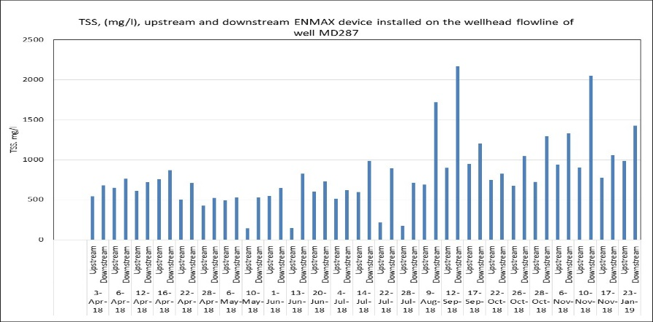
Figure 20: Total Suspended Solids (TSS)Upstream and Downstream ENMAX Device on well MD287.

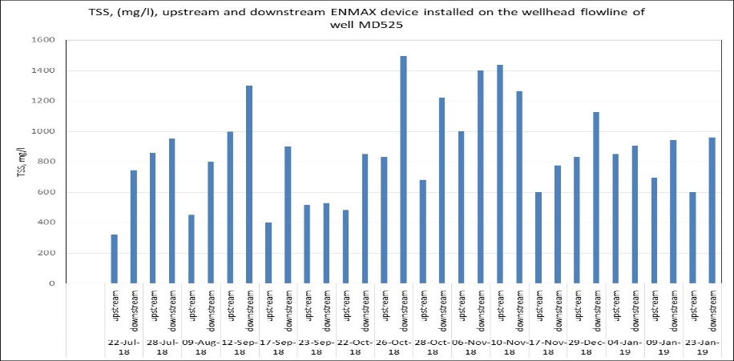
Figure 21: Total Suspended Solids (TSS)Upstream and Downstream ENMAX Device on well MD525.
3.5.2 Calcium Ions, mg/l
Figure 22 & 23 display the calcium ions analyses upstream and downstream the ENMAX device installed on the wellhead flowlines of wells MD287 & MD525. From these figures , it can be noticed that the calcium ions (Ca++) downstream the ENMAX device is higher than the calcium ions (Ca++) upstream the ENMAX devices. these results give an indication that the ENMAX devices are working well.
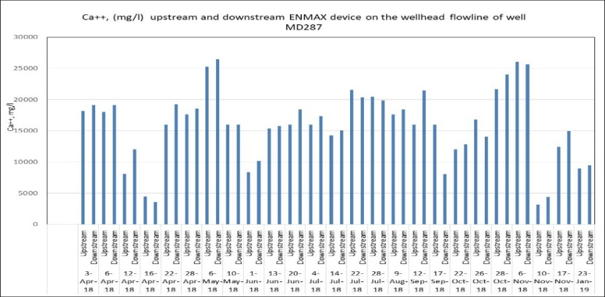
Figure 22: calcium Ions Analysis Upstream and Downstream ENMAX Device on well MD287.
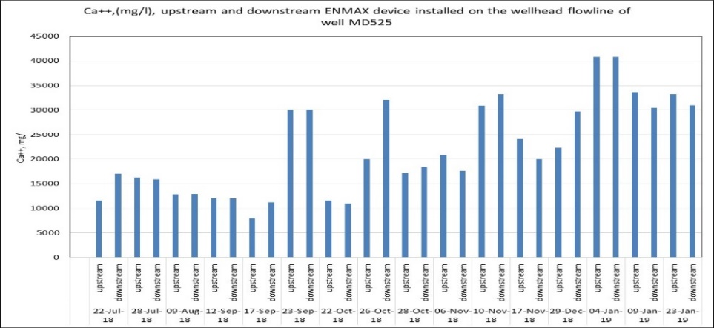
Figure 23: calcium Ions Analysis Upstream and Downstream ENMAX Device on well MD525.

3.5.3 Magnesium Ions, mg/l
Figure 24 & 25 illustrate the magnesium ions analyses upstream and downstream the ENMAX device installed on the wellhead flowlines of wells MD287 & MD525. From these figures , it can be noticed that the magnesium ions (Mg++) downstream the ENMAX device is higher than the magnesium ions (Mg++) upstream the ENMAX devices. these results give an indication that the ENMAX devices are working well.
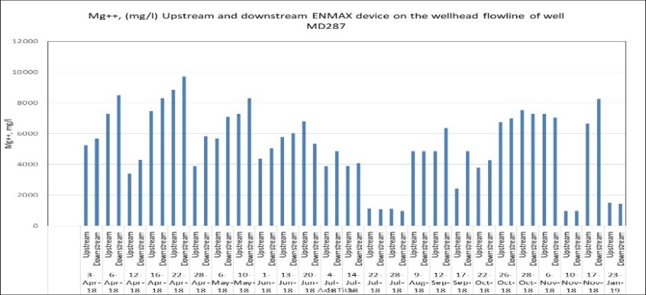
Figure 24: Magnesium Ions Analysis Upstream and Downstream ENMAX Device on well MD287.
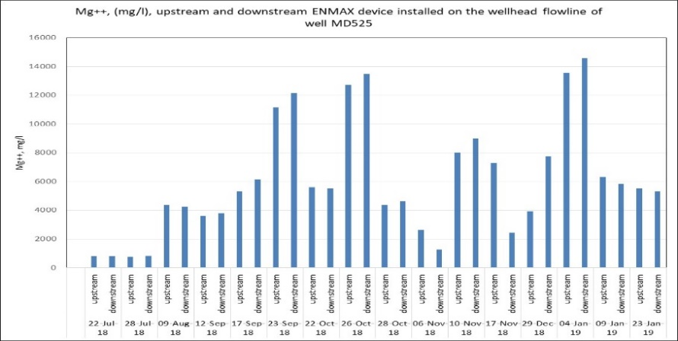
Figure 25: Magnesium Ions Analysis Upstream and Downstream ENMAX Device on well MD525.

3.5.4 Iron Ions, mg/l
Figure 26 & 27 show the iron ions analyses upstream and downstream the ENMAX device installed on the wellhead flowlines of wells MD287 & MD525. From these figures , it can be noticed that the iron ions downstream the ENMAX device is higher than the iron ions upstream the ENMAX devices. these results give an indication that the ENMAX devices are working well.
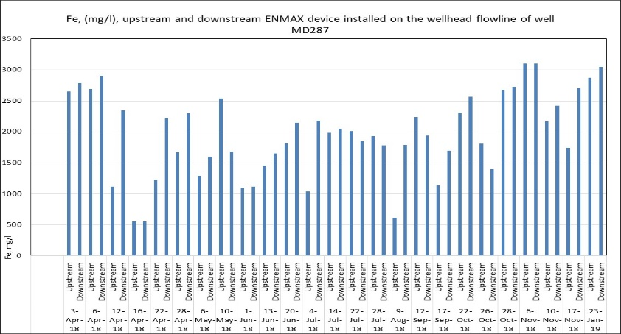
Figure 26: Iron Ions Analysis Upstream and Downstream ENMAX Device on well MD287.
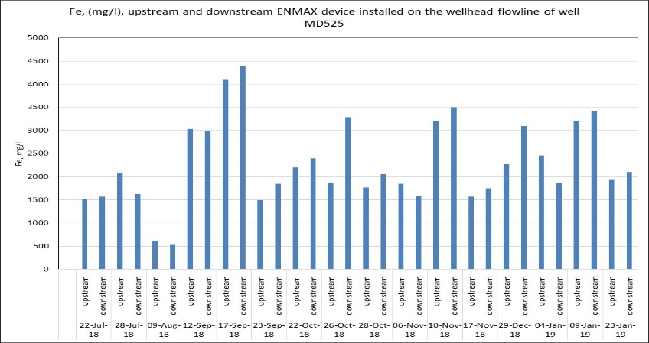
Figure 27: Iron Ions Analysis Upstream and Downstream ENMAX Device on well MD525.

3.5.5 Salinity Ions, mg/l
Figure 28 & 29 reveal the salinity analyses upstream and downstream the ENMAX device installed on the wellhead flowlines of wells MD287 & MD525. From these figures , it can be noticed that the salinity upstream and downstream the ENMAX devices are almost the same. The ENMAX device has no effect on the salinity.
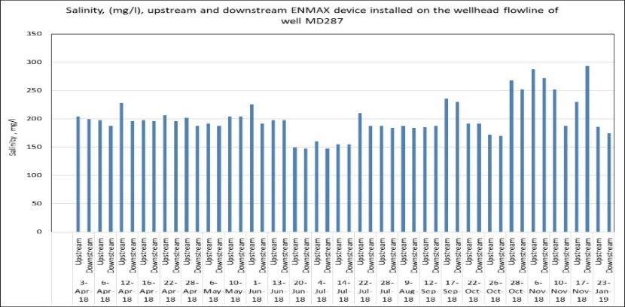
Figure 28: Salinity Analysis Upstream and Downstream ENMAX Device on well MD287.
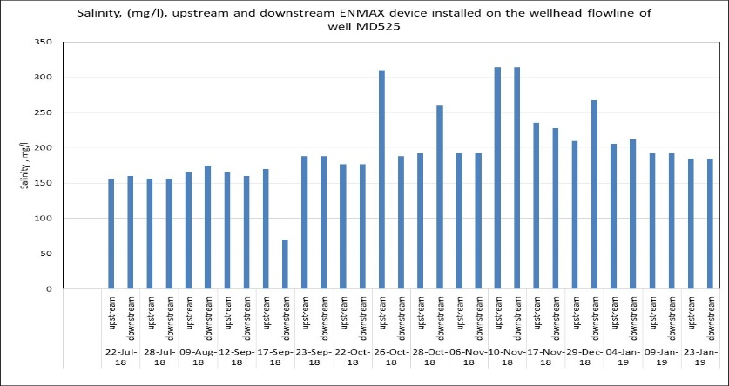
Figure 29: Salinity Analysis Upstream and Downstream ENMAX Device on Well MD525.

3.5.5 pH
Figure 30 & 31 indicate the pH analyses upstream and downstream the ENMAX devices installed on the wellhead flowlines of wells MD287 & MD525. From these figures , it can be noticed that the pH upstream and downstream the ENMAX devices are almost the same. The ENMAX device has no effect on the pH.
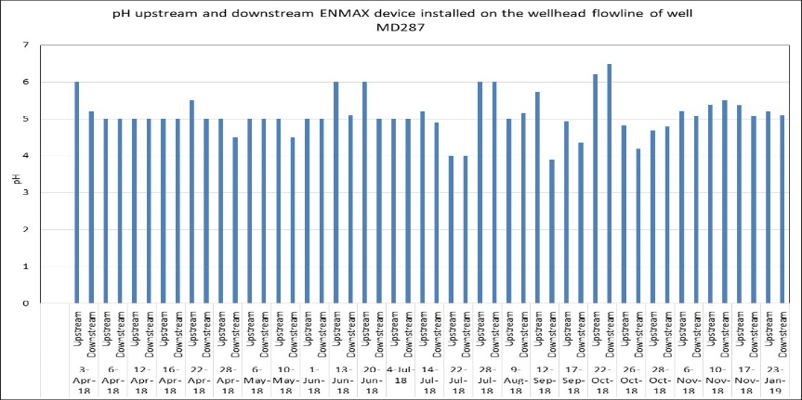
Figure 30: pH Analysis Upstream and Downstream ENMAX Device on well MD287.
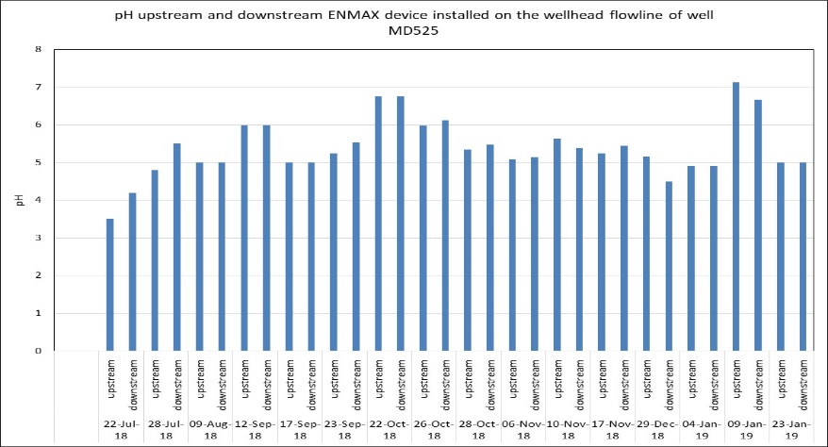
Figure 31: pH Analysis Upstream and Downstream ENMAX Device on well MD525.
3.5.6 Specific Gravity
Figure 32 & 33 illustrate the specific gravity analyses upstream and downstream the ENMAX devices installed on the wellhead flowlines of wells MD287 & MD525. From these figures , it can be noticed that the specific gravity upstream and downstream the ENMAX devices are almost the same. The ENMAX device has no effect on the specific gravity.
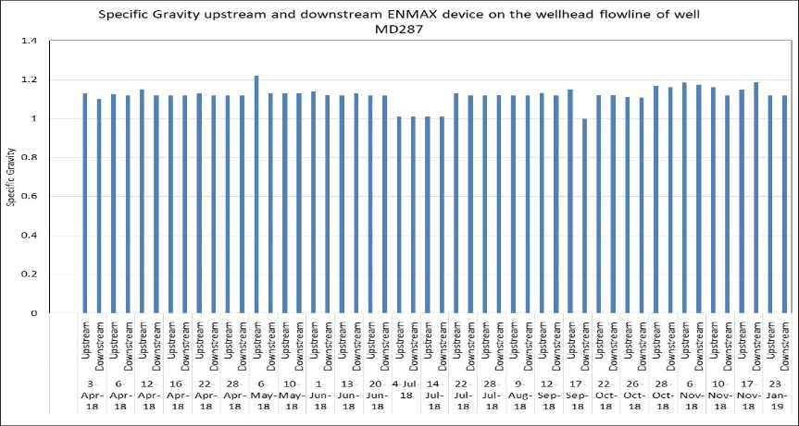
Figure 32: Specific Gravity Analysis Upstream and Downstream ENMAX Device on well MD287.
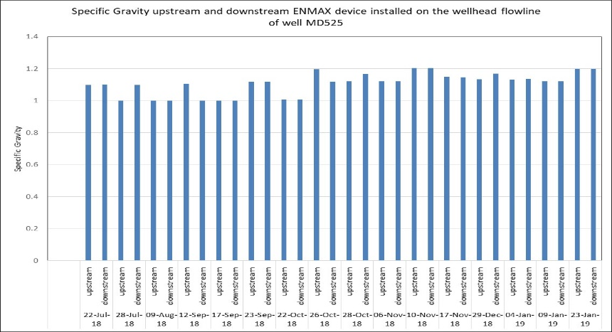
Figure 33: Specific Gravity Analysis Upstream and Downstream ENMAX Device on well MD525.

6. Conclusions
The conclusions can be summarized as follow: -
- The ENMAX devices succeeded to prevent the scales formation on the wellhead flowlines of wells MD287 and MD525 based on the visual inspection before and after ENMAX devices installation. The scales formation was measured before and after ENMAX devices installation and found that the thickness of the scales was decreased after ENMAX installation.
- The ENMAX devices have no effect on the salinity, pH and specific gravity of the fluid based on the experimental analyses performed upstream and downstream ENMAX devices.
- The ENMAX devices have a huge effect on the scales of the fluid , these scales include magnesium, iron , calcium. The analyses of the magnesium, iron, and calcium ions downstream the ENMAX devices is higher than the analyses of the ions upstream the ENMAX devices, this leads to a conclusion that the ENMAX devices was working very well in that time.
- The total suspended solids downstream the ENMAX devices installed on the wellhead flowlines of wells MD525 and MD287 are higher than the total suspended solids upstream the ENMAX devices. This gives a good indication that the ENMAX devices are working very well.
- The weight of the scale formed on the scale coupons downstream the ENMAX devices installed on the wellhead flowlines of wells MD287 and MD525 are higher than the scale formed on the scale coupons upstream ENMAX devices.

7. Recommendations
It has been found that the ENMAX devices succeeded to prevent the formation of scales on the wellhead flowlines of wells MD287, MD525. Its highly recommended to keep the two ENMAX devices installed on the wellhead flowlines of wells MD287, MD525 and install other ENMAX devices either on the well downhole or on the pipeline network to solve the scale problems in Hassi Messaoud field.
7. Nomenclature
Abbreviation | Description
ASTM  BOPD  HP  HT  TSS  WHT  WHP | American Society for Testing and Materials  Barrel Oil Per Day  High Pressure  High Temperature  Total suspended solids  Wellhead Temperature  Wellhead Pressure
References
[1] Y. Benalouane, S. Mokrani, S. Ziani, D. Zerari, O. Dhina, Impregnated Bits Design and Optimization : An Iterative Method for Improving Drilling Performances. Case Study : Hassi Messaoud Cambrian Reservoir in Algeria, SPE/IADC 148558, Middle East Drilling Technology and Exhibition , Muscat , Oman , 24-26 October 2011.
[2] Jordan A. Stringer , Marc A. Saad, Real Results of Optimizing Economics and Operations in a Workover Campaign in the Hassi Messaoud Field using Solid Expendables, SPE150880, Society of Petroleum Engineers , North Africa technical Conference and Exhibition, Cairo, Egypt , 20-22 February 2012.
[3] Ali Berkat, Khelil Kartobi, Amine Mazouzi , Okba Dhina, Hani Qutob, Naiem Barakat, Fudge Grayson, Ayman Marie , A new Systematic and Dynamic UBD Procedures Applied to Prevent Formation Damage , Wellbore Collapse and Improve Oil Production in Hassi Messaoud Field, SPE 119641, SPE/ IADC Drilling Conference and Exhibition , Amsterdam, The Netherland , 17-19 March, 2009.
[4] Bachir Ben Amor, Ali Ferhat, Hani Qutob, James Chopty, Maurizio Arnone, Fritz Schoch and Naiem Barakat Successful Application of Underbalanced Coiled Tubing Drilling in Horizontal Short Radius Re- Entry Well in Hassi Messaoud- Algeria, Offshore Mediterranean Conference and Exhibition in Ravenna, Italy, March 28-30, 2007.
[5] B. Achi, L. Bouazza, R. Zeghouani, A. Ferhat, B. Olaoye, H. Helou, Successful Multi-Stage Hydraulic Fracturing of Openhole Horizontal Wells in Hassi Messaoud Oilfield, International Petroleum Technology Conference , Doha , Qatar, 7-9 December 2009.
[6 ] Li ,J., Tang, M., Ye, Z., Chen, L., Zhou, Y., Scale formation and control in oil and gas fields: A review, Journal of Dispersion Science and Technology, Vol.38, Issue 5, pp. 661- 670, 2017.
[7] Al Rawahi, Y., Shaik, F., Lakkimsetty , R., Studies on Scale Deposition in Oil Industries & Their Control, International Journal for Innovative Research in Science & Technology| Volume 3 , Issue 12 , 2017.
[8] Yan, Y., Tao, Y., Song, J., Wu, B., Qu, C., A Review of Prediction Methods for Oilfield Produced Water Scaling, 3rd International Conference on Green Energy and Sustainable Development IOP Conf. Series: Earth and Environmental Science 651,2021.
[ 9] Al-Samhan, M. , Alanezi , K., Al-Fadhli , J., Al-Attar ,F. , Mukadam , S., George, J., Evaluating Scale Deposition and Scale Tendency of Effluent Water Mix with Seawater for Compatible Injection Water , Journal of Petroleum Exploration and Production Technology ,Vol, 10, pp.2105–2111, 2020.
[10] Askar, M., Abdallah, A., Gad, I., Downhole Scales Associated with October Field Formation Waters and Water Injection Using a Shallow Aquifer, SPE International Conference and Exhibition on Formation Damage Control, Lafayette, Louisiana, USA, February 2020.
[11] Rezaee ,A., Nejad, A., Mansouri, H., Scaling and Corrosion in Oil Production-How Do They Relate to Each other? International Journal of Engineering and Applied Sciences (IJEAS) ISSN: 2394-3661, Volume-4, Issue 6, June 2017.
[12] Kamal, M.S., Hussein, I., Mahmoud, M., Sultan ,A.S., Saad, M., Oilfield scale formation and chemical removal: A review, Journal of Petroleum Science and Engineering, Vol.171, pp. 127-139, 2018.
[13] Olajire, A.A., A Review of Oilfield Mineral Scale Deposits Management Technology for Oil and Gas Production, J. Pet. Sci. Eng. , Vol.135, pp. 723–737, 2015.
[14] Mohammad, A. , Mazumder, J., A Review of Green Scale Inhibitors: Process, Types, Mechanism and Properties , Coatings Journal , Vol.10, Issue 10, pp. 928, 2020.
[15 ] Zheng, H., Chunsheng , P., Comprehensive Research of Scaling Prediction for Gas Reservoir Fluid considering Phase State, Hindawi Geofluids Volume 2019, Article ID 5067345, 2019.
[16] Hamid, S. , De Jesus, O. , Jacinto, C. , Izetti, R., Pinto, H., Droguett, E., Edwards, C., Cassidy, J., Zhang,H., Dagenais, P., Batocchio, M.A., A Practical Method of Predicting Calcium Carbonate Scale Formation in Well Completions , SPE Production & Operations, Vol. 31, Issue 1, pp. 1-11, 2016.
[17] ] Jain, T. , Sanchez, E., Owens-Bennett, E., Trussell, R., Walker, S.L., Liu, H., Impacts of Antiscalants on the Formation of Calcium Solids: Implication on scaling potential of desalination concentrate. Environ. Sci. Water Res. Technol. , Vol.5, pp.1285–1294, 2019.
[18] Wang, X., Deng, G., Ko, S., Lu, A.Y., Zhao, Y., Dai, C., Paudyal, S., Ouyang, B., Mateen, S., Kan, A.T., Tomson, M.B., Improved Scale Prediction for High Calcium Containing Produced Brine and Sulfide Scales, SPE International Oilfield Scale Conference and Exhibition June 24–25, 2020 Virtual.
[19] Chen, T., Wang, Q., Chang,F., Aljeaban,N., Recent Development and Remaining Challenges of Iron Sulfide Scale Mitigation in Sour Gas Wells, International Petroleum Technology Conference ¸ Beijing, China, March 26–28, 2019.
[20] Hashemi, S.H., Hashemi, S.A, Prediction of Scale Formation According to Water Injection Operations in Nosrat Oil Field, Model. Earth Syst. Environ., Vol. 6, pp. 585–589 , 2020.
[21] Ali, A.M., Messaoud, H., Barium Sulphate Deposits, Energy Procedia, Vol. 157, pp. 879-891, 2019.
[22 ] Al‑Samhan, M., Alanezi , K., Al‑Fadhli, J., Al‑Attar , F., Mukadam , S., George, J, Evaluating scale deposition and scale tendency of effluent water mix with seawater for compatible injection water, Journal of Petroleum Exploration and Production Technology , Vol. 10, pp.2105–2111, 2020.
[23] Hamid, K. M. , Elgibaly, A. A., Fekry, M.H., The Possibility of Using Sea Water Injection into Petroleum Reservoirs and Reducing Their Scale Precipitation in Injection and Production Pipelines , Petroleum & Coal, Vol. 61 Issue 5, pp. 1047-1054, 2019.
[24] Azizi, J., Shadizadeh, S.R., Manshad, A.K., Jadidi, N., Effects of pH and Temperature on Oilfield Scale Formation , Iranian Journal of Oil & Gas Science and Technology, Vol. 7, No. 3, pp. 18-31, 2018.
[25] Ghasemian,J., Riahi, S., Ayatollahi, S., Mokhtari, R., Effect of Salinity and Ion Type on Formation Damage Due to Inorganic Scale Deposition and Introducing Optimum Salinity, Journal of Petroleum Science and Engineering, Vol. 177, pp. 270-281, 2019.
[26] Bageri, B., Mahmoud, M. , Shawabkeh, R. , Al-Mutairi, S., Abdulraheem, A., Toward a Complete Removal of Barite (barium sulfate BaSO4) Scale using Chelating Agents and Catalysts , Arab. J. Sci. Eng., Vol. 42, pp. 1667–1674, 2017.
[27] Lu, A.Y., Wang, W., Venkatesan, R., Harouaka, K., Paudyal, S., Saebom ,K., Dai, C., Gao, S., Deng, G., Zhao,Y., Wang, X., Kan, A.T., Tomson, M., The Mechanism of Barium Sulfate Deposition Inhibition and the Prediction of Inhibitor Dosage, Journal of Chemical & Engineering Data, Vol. 64, Issue 11, pp. 4968-4976, 2019.
[28] Gurbanov ,G.R., Adygezalova, M.B., Pashayeva, S.M., Abdullayeva , N.A, Effectiveness of Preventing Scale using an Inhibitory Composition in Laboratory Conditions, Oilfield Business, Vol. 4, Issue 604, pp. 66-69, 2019.
[29] Chao , Y., , Wei , W., Dissolution Study of Field Deposits for Oilfield Scale Mitigation and Remediation , SPE International Conference on Oilfield Chemistry, Galveston, Texas, USA, April 2019.
[30] Lilya, S., Dmitry, T., Rahman A. , Prevention of Scale in the Downhole Equipment and Productive Reservoir During the Oil Well Operation, Journal of Applied Engineering Science, Vol. 19, Issue 2, pp. 363 – 368, 2021.
[31] Erin , T., Myles, J., Helen , W., Sigrid , K., Marija , K., Johansen, K., Development of a Barium Sulphate Scale Inhibitor for Chalk Solid Loaded Conditions, SPE International Conference on Oilfield Chemistry, Galveston, Texas, USA, April 2019.
[32] Sahar, R., Nor, R., Mohamad, W., Amni, W., Khan, R.A., Farima, E., Hatta, S.A., Selection of Barium Sulphate/Barite Dissolver Chemical through Establishment of Standard Laboratory Screening Protocols, Abu Dhabi International Petroleum Exhibition & Conference, Abu Dhabi, UAE, November 2019.
[33] WWW. ENMAX.com.
[34] Sonatrach databank.

